H.T No
Regulations:
A17

Sreenidhi Institute of Science and Technology
(An Autonomous Institution)
Code No:6H213 Date: 13-August-2024 (FN)

B.Tech I-Year II- Semester External Examination, August - 2024 (Supplementary)
ENGINEERING MATHEMATICS-II (Common to ALL)

Time: 3 Hours Max.Marks:75

Note: a) No additional answer sheets will be provided.
b) All sub-parts of a question must be answered at one place only, otherwise it will not be valued.
c) Missing data can be assumed suitably.

Bloom's Cognitive Levels of Learning (BCLL)

Remember | L1 | Apply | L3 | Evaluate | L5
Understand | L2 | Analyze | L4 | Create | L6

Part - A Max.Marks:25
Answer all QUESTIONS

 |  | BCLL | CO(s) | Marks
1 | Find the rank of the matrix 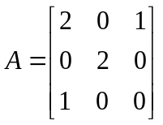 by reducing into normal form | L5 | CO1 | [2M]
2 | Justify that if is an Eigen value of A then 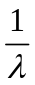 is an Eigen value of 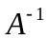 | L2 | CO2 | [2M]
3 | Solve the PD 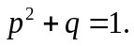 | L3 | CO3 | [2M]
4 | Find 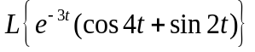 | L3 | CO4 | [2M]
5 | Find the Z-transform of 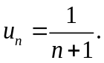 | L5 | CO5 | [2M]
6 | Write the Dirichlet’s conditions to represent a function 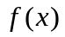 as a Fourier series. | L1 | CO6 | [3M]
7 | Find the value of k such that the vectors 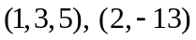and 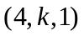 are linearly independent | L5 | CO1 | [3M]
8 | Find 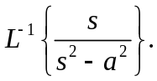 | L5 | CO4 | [3M]
9 | Define Fourier Series. | L1 | CO6 | [3M]
10 | Give any two properties of Laplace transform | L1 | CO4 | [3M]
Part – B Max.Marks:50
ANSWER ANY FIVE QUESTIONS. EACH QUESTION CARRIES 10 MARKS.

 |  |  | BCLL | CO(s) | Marks
11. | a) | Find the rank of a matrix 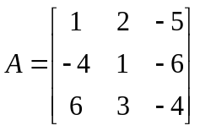 by reducing into echelon form | L5 | CO1 | [5M]
 | b) | solve the system of equations. | L3 | CO1 | [5M]
12. |  | Find the Eigen values and corresponding Eigen vectors of 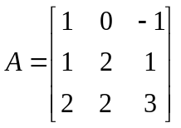 | L5 | CO2 | [10M]
13. | a) | Solve the PDE by eliminating arbitrary function f from 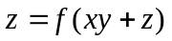 | L3 | CO3 | [5M]
 | b) | Solve the PDE by the method of separation of variables 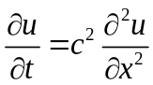 | L3 | CO3 | [5M]
14. |  | Solve the initial value problem 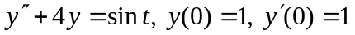 using  Laplace transforms. | L3 | CO4 | [10M]
15. | a) | Find Z-transform of 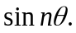 | L5 | CO5 | [5M]
 | b) | Using Convolution theorem prove that 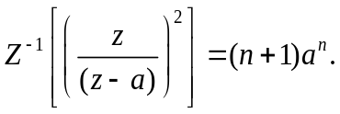 | L4 | CO5 | [5M]
16. |  | Develop the Fourier half range cosine and sine series expansion of 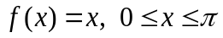. | L6 | CO6 | [10M]
17. | a) | Find the rank of the matrix. 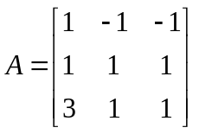 | L5 | CO1 | [4M]
 | b) | Solve the system of equations by Gauss elimination method | L3 | CO2 | [6M]
18. | a) | Evaluate 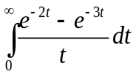 | L5 | CO4 | [5M]
 | b) | Expand 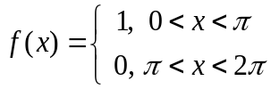 as a Fourier series. | L5 | CO5 | [5M]
-- 00 -- 00 –

